Day 8 – Spring Boot Deep Dive.

Revisit Day 7 Topics. – Spring Boot Starter project.

Web Service – SOA – Service Oriented Arch.

Types of Web Service – SOAP & REST

Monolith vs MicroService (Tightly coupled vs Loosely Coupled)

Created Simple Spring boot Project using STS.

Spring Boot – Is a popular Java based open source framework used for creating loosely coupled Enterprise Application.

Spring Boot supports 3 JVM based lang (Java, Groovy & Kotlin)

It also supports Maven & Graddle build tool.

Framework will take care all the configurations (auto-config), customizing the defaults, integrate with other frameworks.

Developer needs to concentrate business logic only.

REST ful Web Service with Spring Boot.

What is Client-Server Arch.

Multi-Layer(Tier) System

1. Front End (UI/View) – End user will access to this only.
2. Back End (Business Logic/Controller)
3. Database (Data layer)

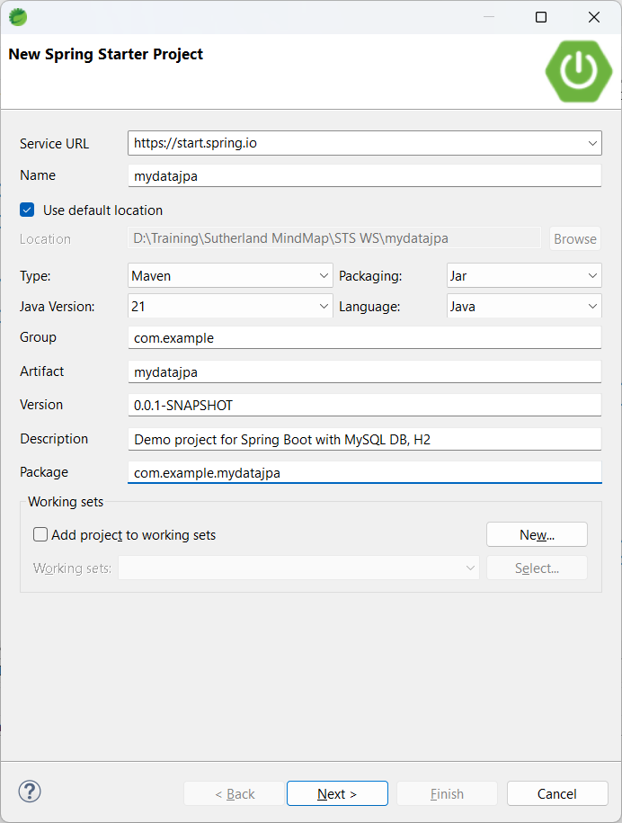

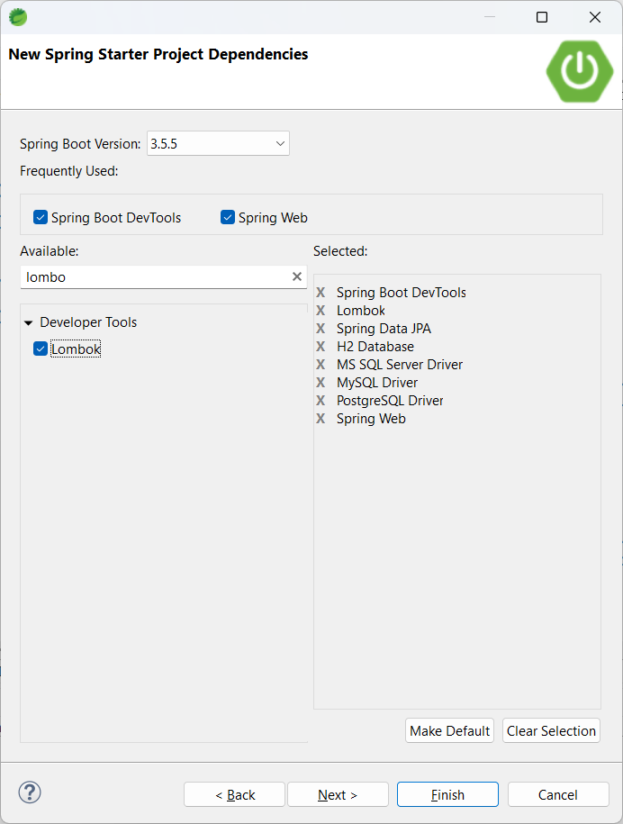

POM.xml file is the backbone of any maven based project.

Annotations – In Java5, annotations are introduced.

It always starts with @ symbol. Annotation – It’s a Meta Data (Data about data).

JAVA Complete Reference Book

1. TOC (Table Of Contents)
2. Index

Before Java5, while creating a Dynamic Web Application, it’s compulsory to have web.xml file (Deployment Descriptor) – All the servlets mapping.

Problem with XML is, it’s both case & space sensitive.

Annotations can be added to

1. Class
2. Interface
3. Methods
4. Variables/properties
5. Parameters
6. Arguments

Spring Boot is called as Opinionated Framework. (It can be customized easily using

1. Properties/yml file
2. Annotation
3. Adding dependencies
4. Java code.

Spring boot is called as Framework of frameworks. (It easily integrates with other framework – mybatis, structus, ibatis, hibernate etc.,)

High Quality Code – Basic rules.

Proper Packaging Structure.

Proper naming convention (package, class, variable, methods)

Base-package (group+artifactId).

All sub-packages from base package only.

Must-have (Compulsory)

1. Model/entity/bean – Data layer
2. Repo (DAO- CRUD operations code DB interactions)
3. Service (Business Logics)
4. Controller (All the end points mapping)

Should Have (Good to have)

1. Config
2. Util
3. Exception

Could have (Optional)

1. Dto (Data Transfer Object)
2. Enums

H2 is a in-memory database (2 mb) jdbc:h2:mem:sampledb –

Embedded DB (h2,derby,hsql)

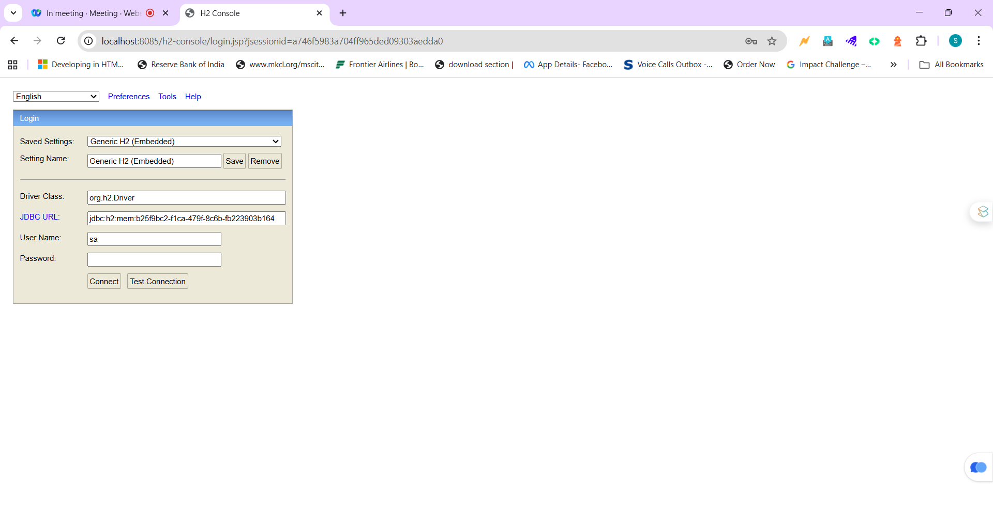

@SpringBootApplication = @SpringBootConfiguration + @EnableAutoConfiguration + @ComponentScan

1. It reads pom.xml file & application.properties file
2. Auto-configure required beans (tomcat, datasource, hibernate, h2-console)
3. Reads all the sub-packages and creates beans for all Components

POJO = Plain Old Java Object

StereoType Annotations

1. @Component
2. @Service
3. @Repository

@RequestMapping == Is a Generic Mapping (GET, PUT, POST, DELETE, PATCH, OPTIONS)

@GetMapping = is a Specific Mapping (Only for GET operation)

@PutMapping

@PostMapping

@DeleteMapping

CRUD – Create/Insert Read Update Delete – POST, GET, PUT, DELETE